BONE EXTRACTION IN X-RAY IMAGES BY ANALYSIS
OF LINE FLECTION
ABSTRACT

Segmentation of X-ray bone images is of concern in many medical applications such as detection of osteoporosis and bone fractures. Segmentation of such images is a challenging process. Varying brightness throughout the image makes it difficult to separate bones from background and soft tissue. Costume made as well as standard segmentation methods, such as active contour and region growing, have been applied to bone X-ray images. Although each method could perform well for some images, due to variety of bone structures and lighting conditions none of these methods can be considered as complete. In this paper we present a new bone segmentation method in which an image goes through preprocessing steps such as noise cancellation and edge detection. Analysis of intensity fluctuations in all rows of the image results in more accurate segmentation of bone regions. Visual evaluation show that the proposed algorithm segments bones better than conventional and some recent bone segmentation approaches.

CHAPTER-1
INTRODUCTION
Segmentation of X-ray bone images is of concern in many medical applications such as detection of osteoporosis and bone fractures. Segmentation of such images is a challenging process. Varying brightness throughout the image makes it difficult to separate bones from background and soft tissue. Costume made as well as standard segmentation methods, such as active contour and region growing, have been applied to bone X-ray images. Although each method could perform well for some images, due to variety of bone structures and lighting conditions none of these methods can be considered as complete. In this project we present a new bone segmentation methods in which an image goes through pre-processing steps such as noise cancellation and edge detection. Visual evaluation show that the proposed algorithm segments bones better than conventional and some recent bone segmentation approaches.
Segmentation of X-ray bone images is of concern in many medical applications such as detection of osteoporosis and bone fractures. Segmentation of such images is a challenging process. Varying brightness throughout the image makes it difficult to separate bones from background and soft tissue. Costume made as well as standard segmentation methods, such as active contour and region growing, have been applied to bone X-ray images. Although each method could perform well for some images, due to variety of bone structures and lighting conditions none of these methods can be considered as complete. Medical image processing plays an important role in the modern medicine. New medical equipment can use automatic methods to diagnose diseases and supervision of their treatments. X-ray imaging is one of the oldest, simplest and most applicable methods in medical diagnosis that is used in many applications such as detecting the location and type of bone fracture, selecting the suitable treatment method and supervising the improvement stages. Separation of bone structure from other regions such as muscle and background is a vital and challenging issue in bone X-ray imaging. Segmentation of bone region helps us to find the region of interest (ROI) and check it for crack, fracture, bone mineral density (BMD) and deformation. However, conventional segmentation methods don’t produce acceptable results on X-ray images.
We start from a gray scale image and smooth it by applying an edge preserving filter called guided filter. Then, we use multilevel canny edge detector to estimate the edges. Before finding the local maxima we rotate the original image to make it almost vertical. Therefore, we can effectively search for the peaks in intensity even in a horizontal long bone image by processing the image rows. Especially, the edges of long bones have the highest intensity in the X-ray images under test. Therefore, the local maximum of the intensity is a good estimation of a bone edge. Our proposed algorithm finds many local maxima (peaks) inside bone region and we use the result of canny edge detection as a guidance to select only proper peaks nearest to bone edges.
X-rays are a type of radiation called electromagnetic waves. X-ray imaging creates pictures of the inside of your body. The images show the parts of your body in different shades of black and white. This is because different tissues absorb different amounts of radiation. Calcium in bones absorbs x-rays the most, so bones look white. Fat and other soft tissues absorb less and look gray. Air absorbs the least, so lungs look black.
TYPES OF X-RAYS

Chest X-ray
If you’re having trouble breathing, experiencing a persistent cough or feeling pain in your chest, your doctor may order a chest x-Ray. A chest x-ray takes an image of your upper body and the bones and organs inside, including the heart, lungs and ribs. With a chest x-ray, your doctor will look for conditions such as pneumonia, tuberculosis, lung cancer, heart size problems, rib or spine fractures, or any chest or lung disease. During the imaging procedure, you’ll stand in front of the x-ray machine and face forward for one image.
Abdominal X-ray
An x-ray of the abdomen provides a look at organs such as the intestines, stomach and spleen. Your doctor might order an abdominal x-ray if you are suffering from unexplained stomach pain or nausea. This tool will help them identify conditions that might be causing your discomfort, such as kidney stones, an intestinal blockage or any injury to abdominal tissue. During this type of x-ray, you’ll likely lie flat on a table with the x-ray machine situated over your abdomen. A technologist will be there to assist you onto and off of the table. They will then capture an image of your front as you hold your breath for a few seconds. Depending on your symptoms, they may wish to take x-rays of your sides or as you stand.

Neck X-ray
If you’re experiencing persistent pain, numbness or weakness in your neck, your doctor might order a neck x-ray. A neck x-ray enables a doctor to view the vertebrae, or spinal bones, in your neck. They can use the x-ray to look for a bone fracture, dislocated joint, infection or inflammation. If a doctor suspects nerve issues or problems with the discs in your spine, they may order an MRI. An MRI is an imaging test that excels at providing highly detailed images of the body’s soft tissues. During a neck x-ray, you will lie on a table and be asked to change positions until your doctor gets the images they need. Typically, a neck x-ray procedure involves two to seven images. A skilled technologist will be by your side to ensure you’re as comfortable as possible while you switch positions.
Problem statement
The bone fracture is a common problem in human beings occurs due to high pressure is applied on bone or simple accident and also due to osteoporosis and bone cancer. The image processing techniques are very useful for many applications such as biology, security, satellite imagery, personal photo, medicine, etc.
Objective
The motivations of this system are: (i) saving time for patients and (ii) to lower the workload of doctors by screening out the easy case. Another motivation for our project is to reduce human errors

CHAPTER-2
DIGITAL IMAGE PROCESSING
2.1 Digital Image Processing :
An image may be defined as a two-dimensional function, f(x, y), where x and y are spatial (plane) coordinates, and the amplitude of f at any pair of coordinates (x, y) is called the intensity or gray level of the image at that point. When x, y, and the amplitude values of f are all finite, discrete quantities, we call the image a digital image. The field of digital image processing refers to processing digital images by means of a digital computer. Note that a digital image is composed of a finite number of elements, each of which has a particular location and value. These elements are referred to as picture elements, image elements, pels, and pixels. Pixel is the term most widely used to denote the elements of a digital image.
Vision is the most advanced of our senses, so it is not surprising that images play the single most important role in human perception. However, unlike humans, who are limited to the visual band of the electromagnetic (EM) spectrum, imaging machines cover almost the entire EM spectrum, ranging from gamma to radio waves. They can operate on images generated by sources that humans are not accustomed to associating with images. These include ultra-sound, electron microscopy, and computer-generated images. Thus, digital image processing encompasses a wide and varied field of applications. There is no general agreement among authors regarding where image processing stops and other related areas, such as image analysis and computer vision, start. Sometimes a distinction is made by defining image processing as a discipline in which both the input and output of a process are images.
We believe this to be a limiting and somewhat artificial boundary. For example, under this definition, even the trivial task of computing the average intensity of an image (which yields a single number) would not be considered an image processing operation. On the other hand, there are fields such as computer vision whose ultimate goal is to use computers to emulate human vision, including learning and being able to make inferences and take actions based on visual inputs. This area itself is a branch of artificial intelligence (AI) whose objective is to emulate human intelligence.
The field of AI is in its earliest stages of infancy in terms of development, with progress having been much slower than originally anticipated. The area of image analysis (also called image understanding) is in between image processing and computer vision. There are no clear-cut boundaries in the continuum from image processing at one end to computer vision at the other. However, one useful paradigm is to consider three types of computerized processes in this continuum: low-, mid-, and high-level processes. Low- level processes involve primitive operations such as image preprocessing to reduce noise, contrast enhancement, and image.
2.2 Definition of Image:
An image is an array, or a matrix, of square pixels (picture elements) arranged in columns and rows.

Fig2.1: An array or a matrix of pixels arranged in columns and rows
In a (8-bit) greyscale image each picture element has an assigned intensity that ranges from 0 to 255. A grey scale image is what people normally call a black and white image, but the name emphasizes that such an image will also include many shades of grey.
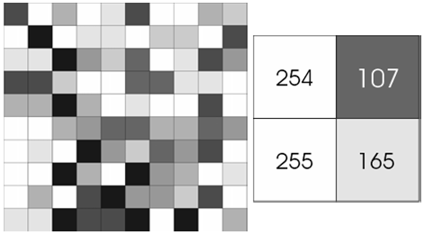
Fig2.2: 8 bit = 256 tones or grayscales image
In Figure 2.2 Each pixel has a value from 0 (black) to 255 (white). The possible range of the pixel values depend on the color depth of the image, here 8 bit = 256 tones or grayscales. A normal grayscale image has 8 bit colour depth = 256 grayscales. A “true colour” image has 24 bit colour depth = 8 x 8 x 8 bits = 256 x 256 x 256 colours = ~16 million colours.
Fig2.3: A true-color image assembled from three grayscale images
Figure 2.3 shows A true-color image assembled from three grayscale images colored red, green and blue. Such an image may contain up to 16 million different colors. Some grayscale images have more grayscales, for instance 16 bit = 65536 grayscales. In principle three grayscale images can be combined to form an image with 281,474,976,710,656 grayscales.
There are two general groups of ‘images’: vector graphics (or line art) and bitmaps (pixel-based or ‘images’).
Some of the most common file formats:
GIF:
An 8-bit (256 color), non-destructively compressed bitmap format. Mostly used for web. Have several sub-standards one of which is the animated GIF.
JPEG:
A very efficient (i.e. much information per byte) destructively compressed 24 bit (16 million colours) bitmap format. Widely used, especially for web and Internet (bandwidth-limited).
TIFF:
The standard 24 bit publication bitmap format.Compresses non-destructively with, for instance, Lempel-Ziv-Welch (LZW) compression.
PS:
Postscript, a standard vector format. Has numerous sub-standards and can be difficult to transport across platforms and operating systems.
Pictures are the most common and convenient means of conveying or transmitting information. A picture is worth a thousand words. Pictures concisely convey information about positions, sizes and inter relationships between objects.
They portray spatial information that we can recognize as objects. Human beings are good at deriving information from such images, because of our innate visual and mental abilities. About 75% of the information received by human is in pictorial form. An image is digitized to convert it to a form which can be stored in a computer's memory or on some form of storage media such as a hard disk or CD-ROM. This digitization procedure can be done by a scanner, or by a video camera connected to a frame grabber board in a computer. Once the image has been digitized, it can be operated upon by various image processing operations.
Image processing operations can be roughly divided into three major categories, Image Compression, Image Enhancement and Restoration, and Measurement Extraction. It involves reducing the amount of memory needed to store a digital image. Image defects which could be caused by the digitization process or by faults in the imaging set-up (for example, bad lighting) can be corrected using Image Enhancement techniques. Once the image is in good condition, the Measurement Extraction operations can be used to obtain useful information from the image. Some examples of Image Enhancement and Measurement Extraction are given below. The examples shown all operate on 256 grey-scale images. This means that each pixel in the image is stored as a number between 0 to 255, where 0 represents a black pixel, 255 represents a white pixel and values in-between represent shades of grey. These operations can be extended to operate on colour images. The examples below represent only a few of the many techniques available for operating on images. Details about the inner workings of the operations have not been given, but some references to books containing this information are given at the end for the interested reader.
2.3 Images and Pictures:
As we mentioned in the preface, human beings are predominantly visual creatures: we rely heavily on our vision to make sense of the world around us. We not only look at things to identify and classify them, but we can scan for differences, and obtain an overall rough feeling for a scene with a quick glance. Humans have evolved very precise visual skills: we can identify a face in an instant; we can differentiate colors; we can process a large amount of visual information very quickly.
However, the world is in constant motion: stare at something for long enough and it will change in some way. Even a large solid structure, like a building or a mountain, will change its appearance depending on the time of day (day or night); amount of sunlight (clear or cloudy), or various shadows falling upon it. We are concerned with single images: snapshots, if you like, of a visual scene. Although image processing can deal with changing scenes, we shall not discuss it in any detail in this text. For our purposes, an image is a single picture which represents something.
It may be a picture of a person, of people or animals, or of an outdoor scene, or a microphotograph of an electronic component, or the result of medical imaging. Even if the picture is not immediately recognizable, it will not be just a random blur.
Image processing involves changing the nature of an image in order to either
- Improve its pictorial information for human interpretation,
- Render it more suitable for autonomous machine perception.
We shall be concerned with digital image processing, which involves using a computer to change the nature of a digital image. It is necessary to realize that these two aspects represent two separate but equally important aspects of image processing. A procedure which satisfies condition, a procedure which makes an image look better may be the very worst procedure for satisfying condition. Humans like their images to be sharp, clear and detailed; machines prefer their images to be simple and uncluttered.
2.4 Images and Digital Images:
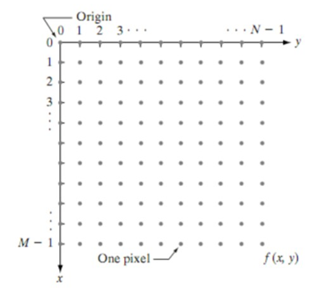
Fig2.4: Coordinate convention used to represent digital mage
Suppose we take an image, a photo, say. For the moment, lets make things easy and suppose the photo is black and white (that is, lots of shades of grey), so no color. We may consider this image as being a two dimensional function, where the function values give the brightness of the image at any given point.
We may assume that in such an image brightness values can be any real numbers in the range (black) (white).A digital image can be considered as a large array of discrete dots, each of which has a brightness associated with it. These dots are called picture elements, or more simply pixels. The pixels surrounding a given pixel constitute its neighborhood. A neighborhood can be characterized by its shape in the same way as a matrix: we can speak of a neighborhood,. Except in very special circumstances, neighborhoods have odd numbers of rows and columns; this ensures that the current pixel is in the centre of the neighborhood.
2.5 Fundamental Steps in Digital Image Processing:
Image acquisition is the first process shown in Fig.2. Note that acquisition could be as simple as being given an image that is already in digital form. Generally, the image acquisition stage involves preprocessing, such as scaling. Image enhancement is among the simplest and most appealing areas of digital image processing.
Basically, the idea behind enhancement techniques is to bring out detail that is obscured, or simply to highlight certain features of interest in an image. A familiar example of enhancement is when we increase the contrast of an image because “it looks better.” It is important to keep in mind that enhancement is a very subjective area of image processing. Image restoration is an area that also deals with improving the appearance of an image. However, unlike enhancement, which is subjective, image restoration is objective, in the sense that restoration techniques tend to be based on mathematical or probabilistic models of image degradation.
Enhancement, on the other hand, is based on human subjective preferences regarding what constitutes a “good” enhancement result. Color image processing is an area that has been gaining in importance because of the significant increase in the use of digital images over the Internet.
The pixels surrounding a given pixel constitute its neighborhood. A neighborhood can be characterized by its shape in the same way as a matrix: we can speak of a neighborhood. Except in very special circumstances, neighborhoods have odd numbers of rows and columns; this ensures that the current pixel is in the centre of the neighborhood. Generally, the image acquisition stage involves preprocessing, such as scaling. Image enhancement is among the simplest and most appealing areas of digital image processing. We may assume that in such an image brightness values can be any real numbers in the range (black) (white).A digital image can be considered as a large array of discrete dots, each of which has a brightness associated with it.
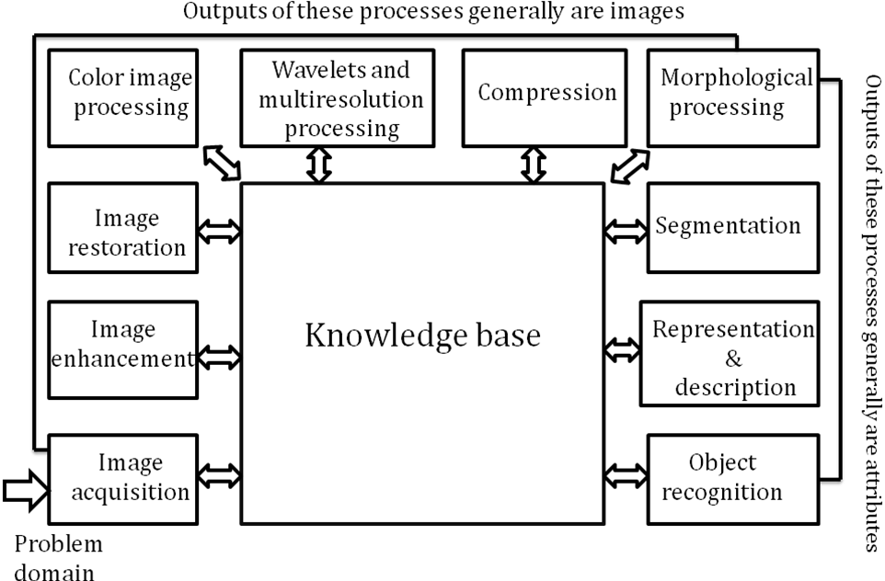
Fig2.5: Fundamental steps in Digital Image Processing
Wavelets are the foundation for representing images in various degrees of resolution. Compression, as the name implies, deals with techniques for reducing the storage required to save an image, or the bandwidth required to transmit it. Although storage technology has improved significantly over the past decade, the same cannot be said for transmission capacity. This is true particularly in uses of the Internet, which are characterized by significant pictorial content. Image compression is familiar (perhapsinadvertently) to most users of computers in the form of image file extensions, such as the jpg file extension used in the JPEG (Joint Photographic Experts Group) image compression standard.
Morphological processing deals with tools for extracting image components that are useful in the representation and description of shape. Segmentation procedures partition an image into its constituent parts or objects. In general, autonomous segmentation is one of the most difficult tasks in digital image processing. A rugged segmentation procedure brings the process a long way toward successful solution of imaging problems that require objects to be identified individually. On the other hand, weak or erratic segmentation algorithms almost always guarantee eventual failure.
Representation and description almost always follow the output of a segmentation stage, which usually is raw pixel data, constituting either the boundary of a region (i.e., the set of pixels separating one image region from another) or all the points in the region itself. In either case, converting the data to a form suitable for computer processing is necessary. The first decision that must be made is whether the data should be represented as a boundary or as a complete region. Boundary representation is appropriate when the focus is on external shape characteristics, such as corners and inflections. Regional representation is appropriate when the focus is on internal properties, such as texture or skeletal shape. In some applications, these representations complement each other. Choosing a representation is only part of the solution for transforming raw data into a form suitable for subsequent computer processing.
A method must also be specified for describing the data so that features of interest are highlighted. Description, also called feature selection, deals with extracting attributes that result in some quantitative information of interest or are basic for differentiating one class of objects from another. Recognition is the process that assigns a label (e.g., “vehicle”) to an object based on its descriptors. We conclude our coverage of digital image processing with the development of methods for recognition of individual objects.

CHAPTER-3
LITERATURE SURVEY
Stolojescu et al. used a clustering method and segmented the image using similarity parameters such as texture and intensity [4]. They finally distinguished the regions using an interactive method. In [5], it is assumed that there is no background and based on this assumption a fuzzy method is proposed to segment the bones. All aforementioned methods have a drawback that they cannot distinguish bone from muscle in some images, especially when the image quality is low or when the bone doesn’t have considerable intensity in comparison to muscle and background because of their density. In other words, these methods operate well on images with proper brightness and high contrast that the separated part has proper sharpness but not on low contrast X-ray images.
[6] proposed a method based on entropy and multilevel LOCO morphologic filter to separate the bone and adjust the result to contour shape. They also used snake model to improve the edge and find a narrow border
. Mahendran [2] used wavelet and morphology operations to determine region of interest in bone images. Sharma and Singh first removed the noise and improved the contrast and then extracted the bone using a proper threshold selected empirically [3]. Stolojescu et al. used a clustering method and segmented the image using similarity parameters such as texture and intensity
High quality image segmentation increasingly depends on image edge detection. Arbeláez et al. (2010) simplified the problem of image segmentation into the problem of edge detection, and designed a high-performance edge detection algorithm gPb. The edge detector combines multiple local cues such as multi-scale local brightness, color, and texture into a powerful global structure based on spectral clustering (Arbelaez et al., 2009). By applying directional gradient operator to each position in the image, the local information of the image is calculated, and the incidence matrix of similarity between pixels is established. Then the feature vector of the encoded image edge information can be solved by using the incidence matrix, and combine this feature vector with image local information to obtain the global edge detection result. Compared with other global methods based on similarity information, the algorithm results have been greatly improved.
Ren et al. (Xiaofeng and Bo, 2012) combined automatic sparse coding with directional gradient and designed an image edge detection algorithm SGD based on Sparse Code Gradients (SCG) unsupervised learning. The algorithm uses K-SVD (Aharon et al., 2006) for dictionary training and orthogonal matching tracking algorithm (Pati et al., 1993) for local neighborhood oriented sparse coding calculation. Before using linear SVM classification, the local information of the image is processed by multi-scale pooling and power transform. Finally, after smoothing and non-maximum suppression, the image edge result graph is generated. Sparse coding can effectively learn the local contrast of the image, and the edge detection performance is obviously better than the coding results of manually designed features.
Lim et al. (2013) applied the idea of Sketch Tokens to the field of image edge detection, and proposed a new edge detection method based on intermediate feature representation of supervised learning and local edge detection (Sketch Tokens). This method extracts the contour from the manually marked sketch edge map to generate a diversified and representative sketch token class (Arbeláez et al., 2010). Then, the sketch token class is grouped by K-means algorithm, which is divided into straight lines to more complex structures. After that, the features of pixels in natural images are extracted, and the classifier is trained by random forest algorithm (Criminisi et al., 2012) using two classes of features, channel index, and self-similarity (Shechtman and Irani, 2007), to determine whether each point of an image pixel belongs to a certain sketch token (i.e., whether it is an edge). Finally, the image edge detection results are output by non-maximal value suppression. This method speeds up the inference of random forest by generating a contour dictionary as the edge features of pixels, which results in good performance in both top-down and bottom-up tasks.
Dollár and Zitnick, (2014) proposed a generalized structured learning algorithm (SE) for edge detection, which transforms the edge detection problem into predicting local segmentation masks given a block of input images. This algorithm uses a random forest structure to capture the structured information inherent to the image edge pixels (Kontschieder et al., 2011), then uses structured labels to determine the splitting function for each branch in the tree. However, since training random forests using structured labels faces the challenge that the structured output space is high-dimensional or complex, and the information gain of structured labels is not clearly defined. Dollár et al. then robustly mapped structured labels to a discrete space where standard information gain measures can be evaluated and each tree predicts an edge pixel label, followed by a random forest to aggregate the final image edge detection results by combining the outputs of multiple trees
Inspired by Structured Random Forests (SRF) (Kontschieder et al., 2011), Zhang et al. (2016) first tried to apply Semi Supervised Learning (SSL) to image edge detection. Compared with standard Random Forests (RF), SRF has the advantages of fast prediction of high-dimensional data, robustness to label noise (Liu et al., 2013) and good support for arbitrary size output, making SRF a good candidate for SSL. At the same time, it is found that sparse representation technology (Maire et al., 2014) has a strong ability to capture the contour structure of the image. Therefore, by embedding the fast sparse coding algorithm and the construction of low dimensional subspace into the training of the whole SRF, Zhang et al. Designed an image edge detection network (SemiContour) based on semi supervised learning. The network can use very limited training data (three label data) to obtain competitive detection results.
O Bandyopadhyay proposed An orthopaedic X-ray captures bone images along with surrounding flesh and muscle components. Segmentation of the bone component with a sharp contour is a challenging task as the bone and flesh regions often have pixels with overlapping intensity range. In this paper, we propose a new technique of contour extraction by integrating an entropy-based segmentation approach with adaptive thresholding. The method eliminates the shortcomings of earlier derivative or deformable model based approaches, and can be fully automated. Experiments with several digital X-ray images reveal encouraging results especially for long-bone X-ray images.

CHAPTER-4
Existing system
Inspection and interpretation of images obtained from X-rays, MRI or CAT scans, analysis of cell images. In medical applications, one is concerned with processing of chest X-rays projection images of trans axial tomography and other medical images that occur in radiology, nuclear magnetic resonance (NMR) and ultrasonic scanning. These images may be used for patient screening and monitoring or for detection of tumors’ or other disease in patients.
X-rays and CT are most frequently used in fracture diagnosis because it is the fastest and easiest way for the doctors to study the injuries of bones and joints. Doctors usually uses x-ray images to determine whether a fracture exists, and the location of the fracture.
Load the Image: Load the medical image containing the bones using the imread function or a similar method in MATLAB.
Preprocess the Image (if necessary): Depending on the quality of your input image, you may need to perform preprocessing operations like noise reduction or contrast enhancement to improve the results of edge detection.
Convert the Image to Grayscale: Convert the loaded image to grayscale using the rgb2gray function if it's a color image.
The Sobel filter is used for edge detection. It works by calculating the gradient of image intensity at each pixel within the image. It finds the direction of the largest increase from light to dark and the rate of change in that direction
SOBEL EDGE DETECTION OPERATOR:
In case of Sobel Edge Detection there are two masks, one mask identifies the horizontal corner and the other mask identifies the vertical corner. The mask which finds the horizontal corner that is equivalent to having the gradient in vertical direction and the mask which computes the vertical corner is equivalent to taking in the gradient in horizontal direction. Sobel masks are given in the figure 1.
-1 | -2 | -1
0 | 0 | 0
1 | 2 | 1
1 | 0 | -1
2 | 0 | -2
1 | 0 | -1

Figure 1: Sobel operators
By passing these two masks over the intensity image the gradient along x direction (Gx) and gradient along the y direction (Gy) can be computed at the different location in the image. Now the strength and the direction of the edge at that particular location can be computed by using the gradients Gx and Gy. The gradient of an image (𝑥,) at location(𝑥,𝑦) is defined as the vector
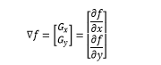
Sobel Filter Analysis:
Filtering is the process of applying masks to images and the application of a mask to an input image produces an output image of the same size as the input image. There are three steps of convolution are given which is necessary for filtering.
Step1. For each pixel in the input image, the mask is conceptually placed lying on that pixel.
Step2. The values of each input image pixel under the mask are multiplied by the value of the corresponding mask weights.
Step3. The result are summed together to yield a single output value that is placed in the output image at the location of pixel being processed on the input.
The pixel values of an original image is shown in the figure 2 and Sobel masks are also shown in figure 1 for horizontal and vertical scan. Now compute Gx and Gy, gradients of the image performing the convolution of Sobel kernels with the image and use zero-padding to extend the image. The process of computing Gx and Gy using convolution and zero padding is given in the figure 3 and figure 4. Gradients Gx and Gy, of the image are shown in the figure 5 and figure 6.
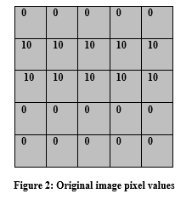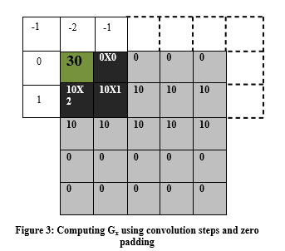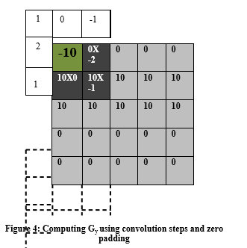
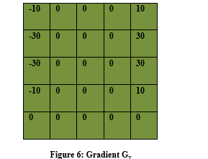
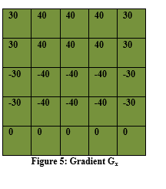

Where Gx is the partial derivative of 𝑓 along x direction and Gy is the partial derivative of 𝑓 along the y direction. Computation of the magnitude of the gradient involves squaring the two components Gx and Gy adding them and takes the square root of this addition.
The approximation of this is taken as magnitude of the gradient to be sum of magnitude of Gx gradient in the x direction plus magnitude of Gy in the y direction
The magnitude tells the strength of the edge at location(𝑥,𝑦), it does not tell anything about the direction of the edge [9][10]. To compute the direction of the gradient𝑓, let (𝑥,) represent the direction angle of the vector ∇𝑓 at (𝑥,), then
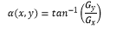
Sobel Edge Operator gives an averaging affect over the image, so effect due to the presence of spurious noise in the image is taken care of some extent by the Sobel operator. Sobel operator also gives a smoothing effect by which we can reduce the spurious edge that can be generated because of the noise present in the image.
So in this way you can see that we can detect both horizontal and vertical edges from an image. Also if you compare the result of sobel operator with Prewitt operator, you will find that sobel operator finds more edges or make edges more visible as compared to Prewitt Operator. This is because in sobel operator we have allotted more weight to the pixel intensities around the edge
Draw backs:
- It can be doesn't identify the exact corners
- Localization is reduce

CHAPTER-5
PROPOSED SYSTEM
The X-ray/CT images are obtained from the hospital that contains normal as well as fractured bones images. In the first step, applying preprocessing techniques such as RGB to grayscale conversion and enhance them by using filtering algorithm to remove the noise from the image. Then it detects the edges in images using edge detection methods and segmented the image. After segmentation, it converts each image into a set of features by using some feature extraction technique. Then we build the classification algorithm based on extracted features. Finally, the performance and accuracy of the proposed system are evaluated. the Canny edge detection technique is one of the standard edge detections techniques. It was first created by John Canny for his Master’s thesis at MIT in 1983, and still outperforms many of the newer algorithms that have been developed. To find edges by separating noise from the image before find edges of image the Canny is a very important method. Canny method is a better method without disturbing the features of the edges in the image afterwards it applying the tendency to find the edges and the serious value for threshold.
The term "Canny operation" is not a standard medical or anatomical term, and it does not refer to a recognized medical procedure or operation related to bones. It's possible that you may have a specific medical context or a particular procedure in mind that you'd like to inquire about, but without more information, it's difficult to provide a precise answer.
If you have questions or concerns about a specific bone-related operation or medical procedure, I would recommend consulting with a medical professional or orthopedic surgeon who can provide you with accurate and personalized information. Please provide more details or clarify your question if you have a specific topic in mind related to bones and medical operations.
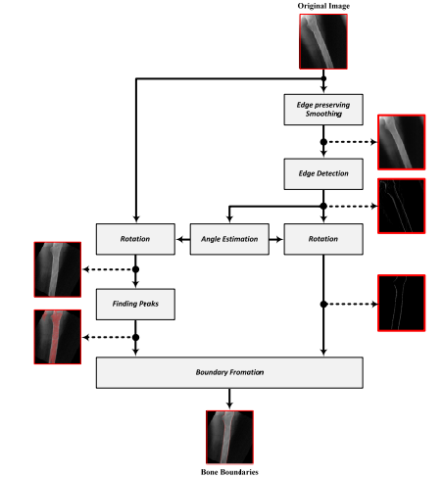
Fig. Diagram of our proposed method
Load the Image: Load the medical image containing the bones using the imread function or a similar method in MATLAB.
Preprocess the Image (if necessary): Depending on the quality of your input image, you may need to perform preprocessing operations like noise reduction or contrast enhancement to improve the results of edge detection.
Convert the Image to Grayscale: Convert the loaded image to grayscale using the rgb2gray function if it's a color image.
The Canny edge detector is an edge detection operator that uses a multi-stage algorithm to detect a wide range of edges in images. Canny also produced a computational theory of edge detection explaining why the technique works.
Apply Canny Edge Detection: Use the edge function in MATLAB to apply the Canny edge detection algorithm.
Apply Canny Edge Detection: Use the Convolve image f(r, c) with a Gaussian function to get smooth image f^(r, c).
f^(r, c) =f(r,c)*G(r,c,6)
• Apply first difference gradient operator to compute edge strength then edge magnitude
and direction are obtained as before.
• Apply non-maximal or critical suppression to the gradient magnitude.
• Apply threshold to the non-maximal suppression image.
Unlike Roberts and Sobel, the Canny operation is not very susceptible to noise. If the
Canny detector worked well it would be superioredge function in MATLAB to apply the Canny edge detection algorithm
Gradient Calculation: Compute the gradient of the smoothed image to find the strength and direction of edges. This is typically done using techniques like Sobel or Prewitt operators.

Non-Maximum Suppression: Suppress non-maximum pixels, which helps to thin the edges by keeping only the local maxima in the gradient magnitude.
Edge Tracking by Hysteresis: Apply edge tracking by using two thresholds, a high threshold and a low threshold. Pixels with gradient magnitudes above the high threshold are considered strong edges, and those between the high and low thresholds are considered potential edges. Edge pixels are connected if they form a continuous path above the high threshold.
a second order derivative defined as
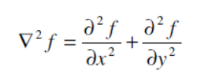
It has two effects, it will smooth the image and it computes the Laplacian, which yields a double edge image. Locating edges then consists of finding the zero crossings between the double edges. The digital implementation of the Laplacian function is usually made through the mask below,
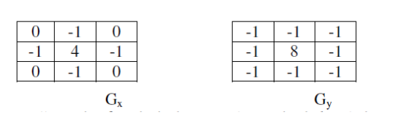
The Laplacian is generally used to found whether a pixel is on the dark or light side of an edge.
Apply high and low thresholds to determine strong and weak edges:
If G(x, y) > High_Threshold, it's a strong edge pixel.
If Low_Threshold < G(x, y) < High_Threshold, it's a weak edge pixel.
If G(x, y) < Low_Threshold, it's not considered an edge pixel.
These equations are used iteratively across the entire image to detect edges.

CHAPTER Vi
SOFTWARE REQUIREMENTS
6.1 INTRODUCTION TO MATLAB
MATLAB is an elite dialect for specialized processing. It coordinates calculation, representation, and programming in a simple to-utilize condition where issues and arrangements are communicated in well-known numerical documentation. Run of the mill utilizes incorporate
- Math and calculation
- Algorithm advancement
- Data procurement
- Modeling, recreation, and prototyping
- Data examination, investigation, and perception
- Scientific and designing illustrations
- Application advancement, including graphical UI building

Fig. 6.1: MATLAB Software
MATLAB is an intuitive framework whose fundamental information component is an exhibit that does not require dimensioning. This enables you to take care of numerous specialized figuring issues, particularly those with framework and vector plans, in a small amount of the time it would take to compose a program in a scalar non intelligent dialect, for example, C or FORTRAN.
The name MATLAB remains for network research facility. MATLAB was initially composed to give simple access to grid programming created by the LINPACK and EISPACK ventures. Today, MATLAB motors join the LAPACK and BLAS libraries, implanting the best in class in programming for framework calculation.
MATLAB has advanced over a time of years with contribution from numerous clients. In college conditions, it is the standard instructional device for early on and propelled courses in arithmetic, designing, and science. In industry, MATLAB is the instrument of decision for high-efficiency research, advancement, and examination.
MATLAB highlights a group of extra application-particular arrangements called tool kits. Important to most employments of MATLAB, tool kits enable you to learn and apply particular innovation. Tool kits are far reaching accumulations of MATLAB capacities (M – records) that stretch out the MATLAB condition to take care of specific classes of issues. Regions in which tool stash are accessible incorporate flag handling, control frameworks, neural systems, fluffy rationale, wavelets, reproduction, and numerous others.

6.3 THE MATLAB SYSTEM
The MATLAB system consists of five main parts
Development Environment
This is the arrangement of devices and offices that assistance you utilize MATLAB capacities and documents. A large number of these instruments are graphical UIs. It incorporates the MATLAB work area and direction window, an order history, a manager and debugger, and programs for review encourage, the workspace, records, and the hunt way.
The MATLAB Mathematical Function Library
This is a tremendous gathering of computational calculations extending from basic capacities, similar to total, sine, cosine, and complex math, to more modern capacities like grid opposite, network Eigen esteems, Bessel capacities, and quick Fourier changes.
The MATLAB Language
This is an abnormal state framework/cluster dialect with control stream proclamations, capacities, information structures, input/yield, and question situated programming highlights. It permits both "programming in the little" to quickly make down to business discard projects, and "programming in the vast" to make substantial and complex application programs.
In the thing part MATLAB programming and the feature, which is to be settled, is the base need. A rate of the purposes of enthusiasm from MATLAB in feature dealing with are:
- Easy to work with; as Images are cross sections
- Built in capacities with respect to complex tasks and figurings (Ex. FFT, DCT, et cetera… )
- Image changing toolbox,
- Supports most picture setups (.bmp, .jpg, .gif, tiff et cetera… )
MATLAB is an elite dialect for specialized processing. It incorporates calculation, perception, and programming in a simple to-utilize condition where issues and arrangements are communicated in well-known scientific documentation. MATLAB remains for network research center, and was composed initially to give simple access to framework programming created by LINPACK (straight framework bundle) and EISPACK (Eigen framework bundle) ventures. MATLAB is along these lines based on an establishment of modern framework programming in which the fundamental component is exhibit that does not require pre dimensioning which to take care of numerous specialized processing issues, particularly those with grid and vector details, in a small amount of time.
MATLAB highlights a group of uses particular arrangements called tool kits. Important to most clients of MATLAB, tool compartments permit learning and applying specific innovation. These are complete accumulations of MATLAB capacities (M-documents) that stretch out the MATLAB condition to tackle specific classes of issues. Territories in which tool kits are accessible incorporate flag handling, control framework, neural systems, fluffy rationale, wavelets, reenactment and numerous others.
Common employments of MATLAB include: Math and calculation, Algorithm improvement, Data procurement, Modeling, recreation, prototyping, Data investigation, investigation, representation, Scientific and designing illustrations, Application advancement, including graphical UI building.
MATLAB is a program that was initially intended to disentangle the usage of numerical straight variable based math schedules. It has since developed into something considerably greater, and it is utilized to execute numerical calculations for an extensive variety of utilizations. The fundamental dialect utilized is very much like standard direct variable based math documentation, however there are a couple of augmentations that will probably cause you a few issues at first.
6.4 BASIC BUILDING BLOCKS OF MATLAB
The essential building square of MATLAB is MATRIX. The major information compose is the cluster. Vectors, scalars, genuine grids and complex framework are taken care of as particular class of this essential information compose. The implicit capacities are enhanced for vector activities. No measurement proclamations are required for vectors or exhibits.
MATLAB WINDOW
The MATLAB works in view of five windows: Command window, Workspace window, Current registry window, Command history window, Editor Window, Graphics window and Online-encourage window.

COMMAND WINDOW
The order window is the place the client composes MATLAB directions and articulations at the incite (>>) and where the yield of those directions is shown. It is opened when the application program is propelled. All directions including client composed projects are composed in this window at MATLAB incite for execution.
WORK SPACE WINDOW
MATLAB characterizes the workspace as the arrangement of factors that the client makes in a work session. The workspace program demonstrates these factors and some data about them. Double tapping on a variable in the workspace program dispatches the Array Editor, which can be utilized to get data.
CURRENT DIRECTORY WINDOW
The present Directory tab demonstrates the substance of the present index, whose way is appeared in the present catalog window. For instance, in the windows working framework the way may be as per the following: C:\MATLAB\Work, showing that index "work" is a subdirectory of the fundamental catalog "MATLAB"; which is introduced in drive C. Tapping on the bolt in the present catalog window demonstrates a rundown of as of late utilized ways. MATLAB utilizes an inquiry way to discover M-documents and other MATLAB related records. Any record keep running in MATLAB must live in the flow catalog or in an index that is on seek way.
COMMAND HISTORY WINDOW
The Command History Window contains a record of the directions a client has entered in the order window, including both present and past MATLAB sessions. Beforehand entered MATLAB directions can be chosen and re-executed from the order history window by right tapping on an order or grouping of directions. This is valuable to choose different alternatives notwithstanding executing the directions and is helpful element while exploring different avenues regarding different directions in a work session.
EDITOR WINDOW
The MATLAB editorial manager is both a word processor specific for making M-documents and a graphical MATLAB debugger. The editorial manager can show up in a window without anyone else, or it very well may be a sub window in the work area. In this window one can compose, alter, make and spare projects in records called M-documents.
MATLAB proofreader window has various draw down menus for undertakings, for example, sparing, seeing, and troubleshooting records. Since it plays out some straightforward checks and furthermore utilizes shading to separate between different components of code, this content manager is prescribed as the device of decision for composing and altering M-capacities.
GRAPHICS OR FIGURE WINDOW
The output of all graphic commands typed in the command window is seen in this window.
ONLINE HELP WINDOW
MATLAB gives online help to all it's worked in capacities and programming dialect develops. The foremost method to get help online is to utilize the MATLAB encourage program, opened as a different window either by tapping on the question mark image (?) on the work area toolbar, or by composing help program at the incite in the direction window. The assistance Browser is an internet browser coordinated into the MATLAB work area that shows a Hypertext Markup Language (HTML) reports. The Help Browser comprises of two sheets, the assistance pilot sheet, used to discover data, and the presentation sheet, used to see the data. Clear as crystal tabs other than guide sheet are utilized to play out a pursuit.
6.5 MATLAB FILES
MATLAB has three types of files for storing information. They are: M-files and MAT-files.
M-Files
These are standard ASCII content record with 'm' augmentation to the document name and making own grids utilizing M-documents, which are content documents containing MATLAB code. MATLAB manager or another word processor is utilized to make a document containing similar articulations which are composed at the MATLAB order line and spare the record under a name that closures in .m. There are two sorts of M-records:
1. Content Files
It is a M-document with an arrangement of MATLAB directions in it and is executed by composing name of record on the order line. These documents deal with worldwide factors as of now present in that condition.
2. Capacity Files
A capacity record is additionally a M-document aside from that the factors in a capacity record are for the most part neighborhood. This sort of documents starts with a capacity definition line.
3.Tangle Files
These are twofold information documents with .tangle augmentation to the record that are made by MATLAB when the information is spared. The information written in an extraordinary organization that no one but MATLAB can read. These are situated into MATLAB with 'stack' order.
The MATLAB System:
The MATLAB framework comprises of five primary parts:
Advancement Environment:
This is the arrangement of apparatuses and offices that assistance you utilize MATLAB capacities and documents. A significant number of these devices are graphical UIs. It incorporates the MATLAB work area and Command Window, a direction history, a manager and debugger, and programs for review encourage, the workspace, documents, and the pursuit way.
The MATLAB Mathematical Function:
This is a tremendous gathering of computational calculations running from rudimentary capacities like whole, sine, cosine, and complex number juggling, to more refined capacities like network converse, grid eigen esteems, Bessel capacities, and quick Fourier changes.
The MATLAB Language:
This is an abnormal state lattice/exhibit dialect with control stream explanations, capacities, information structures, input/yield, and question arranged programming highlights. It permits both "programming in the little" to quickly make no-nonsense discard projects, and "programming in the huge" to make finish expansive and complex application programs.
Designs
MATLAB has broad offices for showing vectors and frameworks as charts, and additionally commenting on and printing these diagrams. It incorporates abnormal state capacities for two-dimensional and three-dimensional information perception, picture handling, activity, and introduction designs. It likewise incorporates low-level capacities that enable you to completely modify the presence of designs and in addition to manufacture finish graphical UIs on your MATLAB applications.
The MATLAB Application Program Interface (API)
This is a library that enables you to compose C and FORTRAN programs that associate with MATLAB. It incorporates offices for calling schedules from MATLAB (dynamic connecting), calling MATLAB as a computational motor, and for perusing and composing MAT-records.
6.6 GRAPHICAL USER INTERFACE (GUI)
MATLAB's Graphical User Interface Development Environment (GUIDE) gives a rich arrangement of instruments for consolidating graphical UIs (GUIs) in M-capacities. Utilizing GUIDE, the procedures of spreading out a GUI (i.e., its catches, fly up menus, etc.)and programming the activity of the GUI are isolated helpfully into two effortlessly oversaw and moderately autonomous errands. The subsequent graphical M-work is made out of two indistinguishably named (overlooking expansions) documents:
A record with augmentation .fig, called a FIG-document that contains an entire graphical depiction of all the capacity's GUI articles or components and their spatial game plan. A FIG-record contains double information that does not should be parsed when he related GUI-based M-work is executed.
A record with augmentation .m, called a GUI M-document, which contains the code that controls the GUI task. This record incorporates capacities that are considered when the GUI is propelled and left, and callback works that are executed when a client connects with GUI protests for instance, when a catch is pushed.
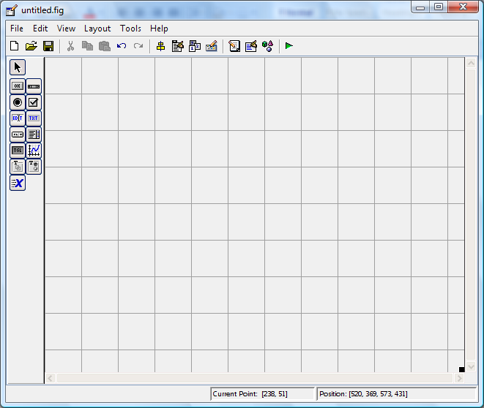
To dispatch GUIDE from the MATLAB order window, type control filename Where filename is the name of a current FIG-document on the present way. In the event that filename is precluded, GUIDE opens another (i.e., clear) window.

RESULTS
This approach proposed the algorithm for automatic detection of fracture in femur bone so as to facilitate more accurate and broad classification. This work is done using explicit coding in MATLAB. Initially, the X-ray image is stored in RGB, so conversion is done to grayscale prior to image preprocessing stage. The collection of X-ray images is taken from radiograph film resolution shown in fig 7.1 which also taken as training data for classification. This approach is developed for detection of fracture in femur bone using modified version sobel edge detection shown in fig 7.2 and result is compared with other edge detection techniques to process the image and the sobel edge detection is used as an approach to get clear edge of the bone to process the image and the canny edge detection is shown in fig 7.3 used as an approach to get clear edge of the bone

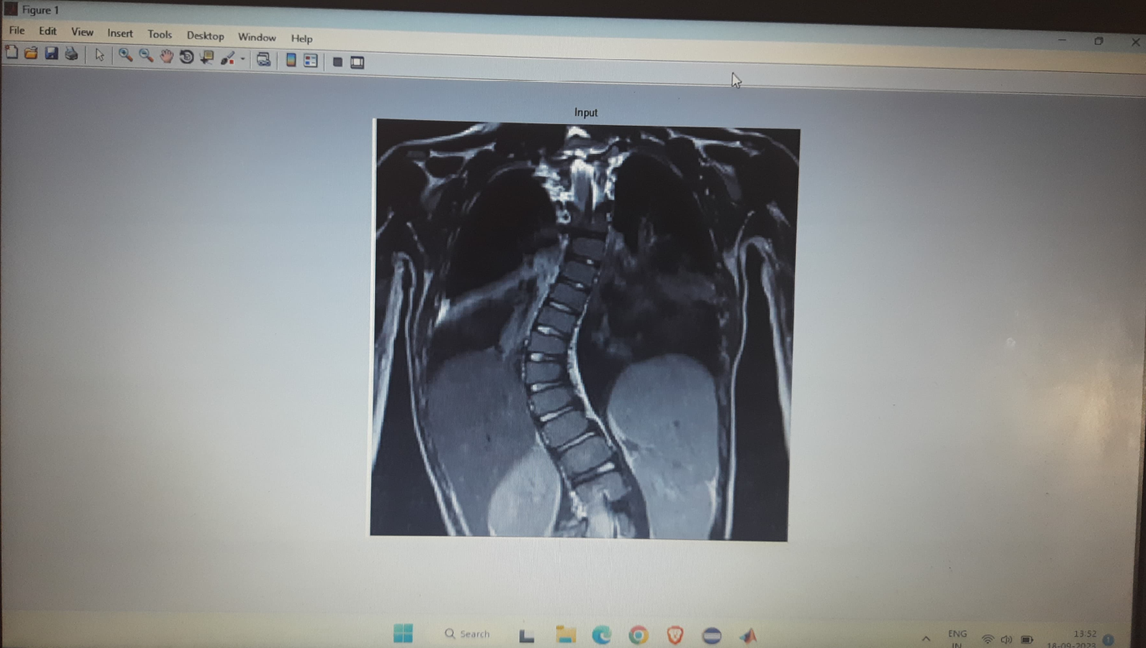
Fig 7.1 : browse the input x-ray image
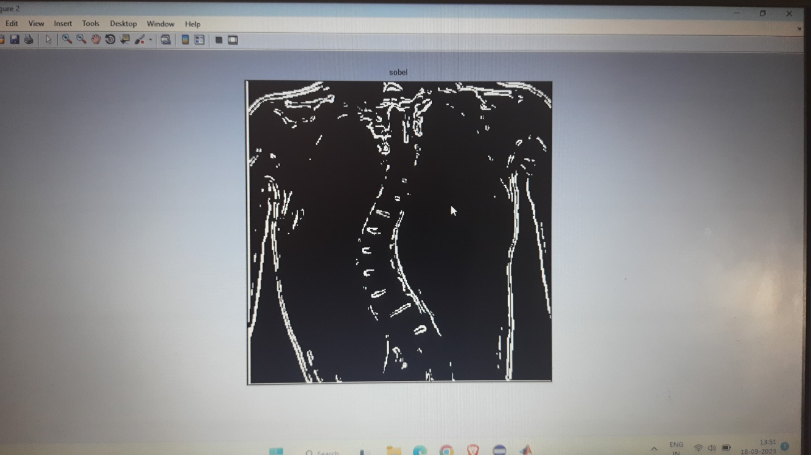
Fig 7.2 . sobel edge detection used in processed X-ray image.
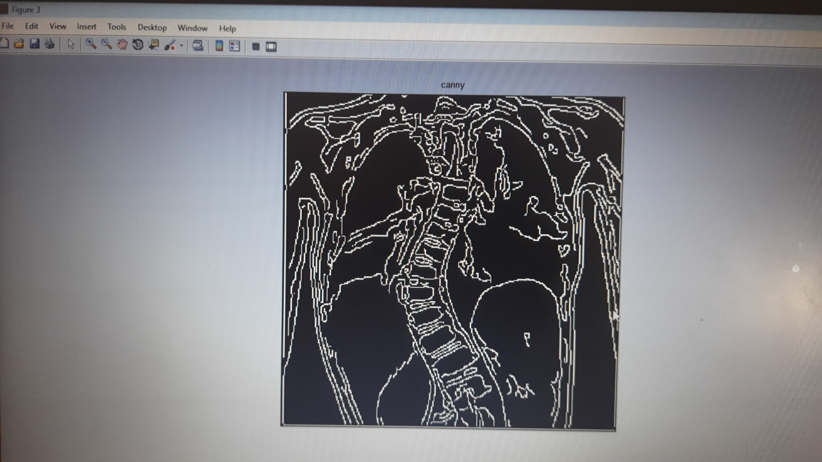
Fig 7.3. Canny edge detection used in processed X-ray image.

Conclusion
We presented a novel method for segmentation of bone X-ray images. Our method first smoothes the original gray scale image using an edge preserving filter and detects the edges. We observed that near the boundary of bone the intensity values are higher than those in the middle of bone. Therefore, we search along each row of image to find the local maxima in intensity and preserve only those edges that are nearest to the peaks.

REFERENCE
[1] C. Stolojescu-Crisan, S. Holban, “A Comparison of X-ray Image Segmentation Techniques,” Advances in electrical and computer engineering, vol. 13, no. 3, pp.85-92, 2013.
[2] S. K. Mahendran, S. S. Baboo, “Enhanced automatic X-ray bone image segmentation using wavelets and morphological operators,” International Conference on Information and Electronics Engineering, pp. 125-129, 2011.
[3] P. Sharma, J. M. Singh, “A Novel Approach towards X-ray Bone Image Segmentation using Discrete Step Algorithm,” International Journal of Emerging Trends & Technology in Computer Science, vol. 2, no.5, pp. 191-195, 2013.
[4] C. Stolojescu-Crisan, S. Holban, “An Interactive X-ray Image Segmentation Technique for Bone Extraction,” International Work-Conference on Bioinformatics and Biomedical Engineering, pp. 1164-1171, 2014.
[5] M. A. Ali, L. S. Dooley, G. C. Karmakar, “Object based image segmentation using fuzzy clustering,” IEEE International Conference on Acoustics, Speech and Signal Processing, vol. 2, pp. 1-4, 2006.
[6] O. Bandyopadhyay, B. Chanda, B. B. Bhattacharya, “Entropybased automatic segmentation of bones in digital X-ray images,” In Pattern Recognition and Machine Intelligence, pp. 122-129, 2011.
[7] O. Bandyopadhyay, A. Biswas,B. Chanda, B. B. Bhattacharya, “Bone contour tracing in digital X-ray images based on adaptive thresholding,” Pattern Recognition and Machine Intelligence vol. 852, pp. 465-473, 2013.
[8] K. He, J. Sun, X. Tang, “Guided image filtering,” IEEE Transactions on Pattern Analysis and Machine Intelligence, vol. 35, no.6, pp. 1397-1409, 2013.
[9] A. Hernández-Vela, C. Gatta, S. Escalera, L. Igual, V. MartinYuste, M. Sabaté, P. Radeva, “Accurate Coronary Centerline Extraction, Caliber Estimation, and Catheter Detection in Angiographies,” IEEE Transactions on Information Technology in Biomedicine, vol. 16, no. 6, pp. 1332-1340, 2012.
[10] C. Tomasi, R. Manduchi, “Bilateral filtering for gray and color images,” IEEE Conference on Computer Vision, 839-846 1998.
[11] N. Otsu, “A Threshold Selection Method from Gray-Level Histograms,” IEEE Transactions on Systems , Man, and Cybernetics, vol. 9, no. 1, pp. 62-66, 1979.
[12] Uniformed Services University of the Health Sciences, http://rad.usuhs.edu/
[13] X- ray Fracture Shaft Femur, www.boneandspine.com/xrayfracture-shaft-femur/

